Example 1A - UAI 655

Exam1 – oral part – summer 2022
Name of student
Date

Create the Jupyter (ipynb) program in your home directory in your virtual machine /home/biopython/ and name it “example1-yourname.ipynb”. Put your name on the top of your program.

Put the following tasks into your program.

Work with Entrez database, Pandas, Numpy and Matplotlib

Read into the Pandas dataframe the excel file
- The link to the file is https://github.com/MartaVohnoutovaBukovec/IOS-655-Python-a-Bash/blob/master/13B_exam2021_source_cleaned_shorten.xlsx?raw=true
- The name of all species put both in row names and column names, so you will have square set, make the names indexes named "Names of organisms" – see example
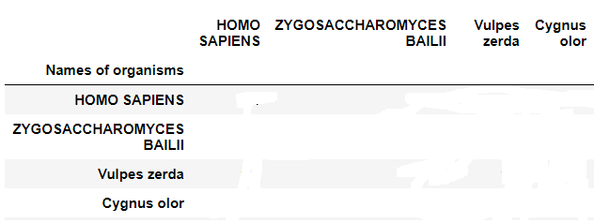

Create dictionary with names from Entrez database
- Create dictionary named lineages_dictionary and put the data from Entrez database db="Taxonomy" for each species. You will have:
{'HOMO SAPIENS': 'cellular organisms; Eukaryota; Opisthokonta; Metazoa; Eumetazoa; Bilateria; Deuterostomia; Chordata; Craniata; Vertebrata; Gnathostomata; Teleostomi; Euteleostomi; Sarcopterygii; Dipnotetrapodomorpha; Tetrapoda; Amniota; Mammalia; Theria; Eutheria; Boreoeutheria; Euarchontoglires; Primates; Haplorrhini; Simiiformes; Catarrhini; Hominoidea; Hominidae; Homininae; Homo',…………
- Adjust the shape - e.g. get rid of ;

Count data to dataframe

Fill the dataframe with the following. Find how many parts of the taxonomy have species in common -e.g.
  - HOMO SAPIENS Names of organisms
    - HOMO SAPIENS 1.0
    - ZYGOSACCHAROMYCES BAILII 0.1
- Homo Sapiens with homo Sapiens has all taxonomy same = 1.0, Homo Sapiens and ZYGOSACCHAROMYCES BAILII has in common only 10% = 0.1

lineages_dictionary['ZYGOSACCHAROMYCES BAILII']

'cellular organisms; Eukaryota; Opisthokonta; Fungi; Dikarya; Ascomycota; saccharomyceta; Saccharomycotina; Saccharomycetes; Saccharomycetales; Saccharomycetaceae; Zygosaccharomyces'

lineages_dictionary['HOMO SAPIENS']

'cellular organisms; Eukaryota; Opisthokonta; Metazoa; Eumetazoa; Bilateria; Deuterostomia; Chordata; Craniata; Vertebrata; Gnathostomata; Teleostomi; Euteleostomi; Sarcopterygii; Dipnotetrapodomorpha; Tetrapoda; Amniota; Mammalia; Theria; Eutheria; Boreoeutheria; Euarchontoglires; Primates; Haplorrhini; Simiiformes; Catarrhini; Hominoidea; Hominidae; Homininae; Homo'

- Fill the dataframe with relations where diagonal will be 1.0 where diagonal will be 1.0
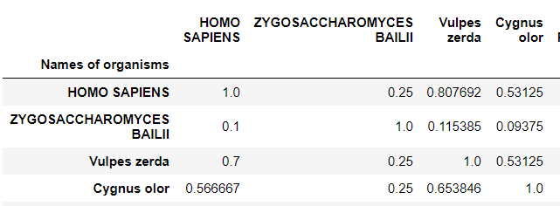

Make the heatmap graph
- For the heatmap graph you can use either Seaborn heatmap or Matplotlib imshow
- For the graph use only first 12 : 12 subsquare from the dataframe
- The numbers must be printed in each small square of the graph
- The title will be 'Taxonomy relations between species'
- The labels of the axes will be 'Species from Entrez database' in both x and y axes
- The ticks of axes will be the names of species, the font size is 12, rotation 90 to the axe
- Save the graph as png file with your name and send me it together with your ipynb file

What is expected

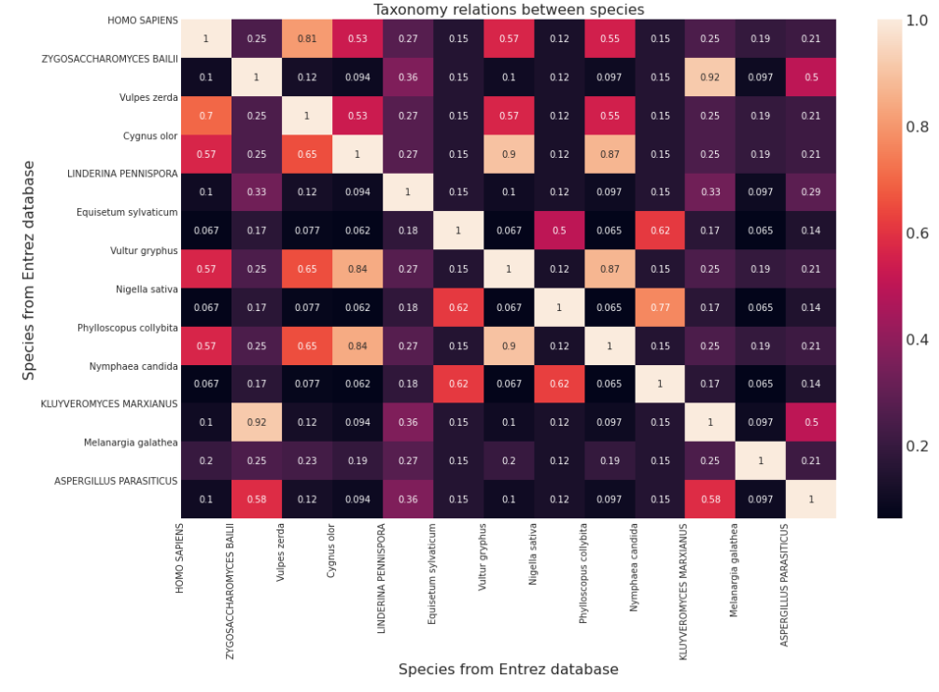

- Biopython - Codontable

In the same Jupyter (ipynb) program in your home directory.
Put the following tasks into your program.

Create protein fasta files - start codons and stop codons
- Small theory
About stop and start codons see more
https://en.wikipedia.org/wiki/Genetic_code#RNA_codon_table https://en.wikipedia.org/wiki/DNA_codon_table
https://www.ncbi.nlm.nih.gov/orffinder/
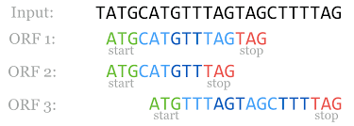
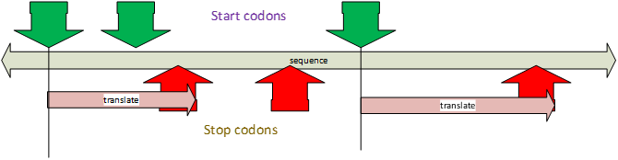
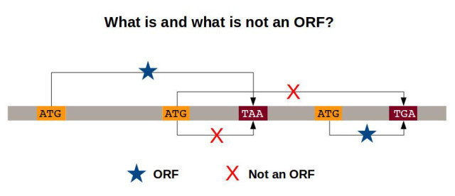
- Requirements
Codontable
codontable1 = {
'ATA':'I', 'ATC':'I', 'ATT':'I', 'ATG':'M',
'ACA':'T', 'ACC':'T', 'ACG':'T', 'ACT':'T',
'AAC':'N', 'AAT':'N', 'AAA':'K', 'AAG':'K',
'AGC':'S', 'AGT':'S', 'AGA':'R', 'AGG':'R',
'CTA':'L', 'CTC':'L', 'CTG':'L', 'CTT':'L',
'CCA':'P', 'CCC':'P', 'CCG':'P', 'CCT':'P',
'CAC':'H', 'CAT':'H', 'CAA':'Q', 'CAG':'Q',
'CGA':'R', 'CGC':'R', 'CGG':'R', 'CGT':'R',
'GTA':'V', 'GTC':'V', 'GTG':'V', 'GTT':'V',
'GCA':'A', 'GCC':'A', 'GCG':'A', 'GCT':'A',
'GAC':'D', 'GAT':'D', 'GAA':'E', 'GAG':'E',
'GGA':'G', 'GGC':'G', 'GGG':'G', 'GGT':'G',
'TCA':'S', 'TCC':'S', 'TCG':'S', 'TCT':'S',
'TTC':'F', 'TTT':'F', 'TTA':'L', 'TTG':'L',
'TAC':'Y', 'TAT':'Y', 'TAA':'-', 'TAG':'-',
'TGC':'C', 'TGT':'C', 'TGA':'-', 'TGG':'W',
'AUA':'I', 'AUC':'I', 'AUU':'I', 'AUG':'M',
'ACU':'U', 'AAU':'N', 'AGU':'S', 'CUA':'L',
'CUG':'L', 'CUG':'L', 'CUU':'L', 'CCU':'P',
'CAU':'H', 'CGU':'R', 'GUA':'V', 'GUC':'V',
'GUG':'V', 'GUU':'V', 'GCU':'A', 'GAU':'D',
'GGU':'G', 'UCA':'S', 'UCC':'S', 'UCG':'S',
'UCU':'S', 'UUC':'F', 'UUU':'F', 'UUA':'L',
'UUG':'L', 'UAC':'Y', 'UAU':'Y', 'UAA':'-',
'UAG':'-', 'UGC':'C', 'UGU':'C', 'UGA':'-',
'UGG':'W'}
Create Jupyter program which
- Read nucleotide fasta files
- /home/marta/my_biopython/files/hepatitis_b_genome.fasta
- /home/marta/my_biopython/files/ebov_2014.fasta
- /home/marta/my_biopython/files/ebov_2007.fasta
- Take into clipboard the /home/marta/my_biopython/files/codontable.txt and put it into your program
- From nucleotide fasta file create (print on the screen or write in a disk) protein fasta file. The header take as it is. Replace the sequence.
- Find start_codon in sequence start_codon = ["ATG"]
- Find one of stop_codons stop_codon = ["TAG","TAA","TGA"]

- All between the start_codon and the first stop_codon replace according to the codontable. The stop_codons are “-” in the codontable, omit them.
- Continue till the end of the nucleotide fasta file.
- Consider that the fastafile can be multiple (more headers and more sequencies

